1- Intro Full Stack.mp4Links to an external site.

2- Intro full Stack -Middleware.mp4Links to an external site.

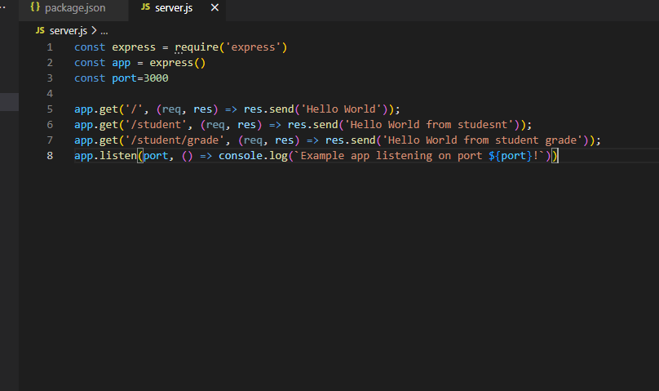

3- Test Mongo DB Database.mp4Links to an external site.

4-Connectig to Mongo DB Using Code.mp4Links to an external site.

5-MVC Concept.mp4Links to an external site.

6-Refactoring and MVC Best Prcatices.mp4Links to an external site.

7- CRUD Operations Mongo DB.mp4Links to an external site.

8-Final Refactoring to get element by ID.mp4